HAZTRACK - HAZARDOUS WASTE MANAGEMENT &
TRACKING SYSTEM

A PROJECT REPORT
Submitted by
Shravan. J - 310624205252
in partial fulfillment for the award of the Degree

of

BACHELOR OF TECHNOLOGY

in

DEPARTMENT OF
INFORMATION TECHNOLOGY


EASWARI ENGINEERING COLLEGE,
(AN AUTONOMOUS INSTITUTION) – AFFILIATED TO ANNA UNIVERITY, CHENNAI

OCTOBER 2026


EASWARI ENGINEEING COLLEGE

BONAFIDE CERTIFICATE

Certified that this mini project report titled “HAZTRACK - HAZARDOUS WASTE MANAGEMENT & TRACKING SYSTEM” is the Bonafide work of “SHRAVAN. J - 310624205252”, who carried out the project work under my supervision.

HEAD OF THE DEPARTMENT SUPERVISOR


EASWARI ENGINEEING COLLEGE

Certificate of Viva-voce-Examination

This is to certify that the Viva Voce Examination of the Project Work entitled “HazTrack – Hazardous Waste Management & Tracking System” submitted by Mr.SHRAVAN. J - 310624205252 in partial fulfillment of the requirements for the award of the degree of Bachelor of Technology in Information Technology was conducted on 15th October 2026 in the Department of Information Technology, Easwari Engineering College, Ramapuram – Chennai.

Internal Examiner External Examiner

Name : Name :
Designation: Designation :
Address : Address :

Date:

ABSTRACT

Hazardous waste generated by laboratories and industries must be collected, transported, treated and disposed of with accurate records and regulatory oversight. Paper-based registers and disconnected spreadsheets make it difficult to verify quantities, identify delays, maintain evidence and establish accountability when waste changes hands. HazTrack is a centralized web-based Hazardous Waste Management & Tracking System designed to record the waste lifecycle from generation to final disposal. The proposed platform provides role-based workspaces for generators, transporters, treatment/storage/disposal facilities (TSDFs) and regulators. Waste records can include category, quantity, source, handling instructions and supporting documents. Shipment and handover events record timestamps, responsible users, quantity differences and transport status. QR-based identification supports quick record retrieval, while GPS/status updates provide visibility during transportation. Workflow validation restricts invalid lifecycle transitions and cryptographic hashes help make audit records tamper-evident. Event-driven alerts can identify quantity mismatches, delays, missing documents and incidents, then route notifications to the responsible user. A configurable voice-alert interface can announce high-priority investigation requests. The system aims to improve traceability, data consistency, response time and compliance documentation. It is a decision-support and record-management platform; actual regulatory compliance still depends on correct data entry, authorized procedures and validation against applicable rules.

Keywords: Hazardous waste, lifecycle tracking, chain of custody, QR code, GPS, audit trail, compliance, real-time alerts.

ACKNOWLEDGEMENT

We express our sincere gratitude to the Principal Dr.P.Deiva Sundari and the Management of our college for providing us with the opportunity to carry out this project work.
We convey our heartfelt thanks to the Head of the Department, Department of INFORMATION TECHNOLOGY, for the continuous encouragement and support.
We are extremely thankful to our Project Guide, INFORMATION TECHNOLOGY for valuable guidance, suggestions, and motivation throughout the completion of this project.
We would also like to extend our gratitude to all the faculty members of the Department of INFORMATION TECHNOLOGY for their support.
Finally, we thank our parents and friends for their constant encouragement and help during the course of this project.

TABLE OF CONTENTS

CHAPTER NO. TITLE PAGE No.
— | Abstract | 4
— | Acknowledgement | 5
1 | Introduction | 7
2 | Related Work | 8
3 | System Analysis | 9
4 | System Design | 10–11
5 | Implementation | 12
6 | Conclusion & Future Work | 13
— | Appendix: Source Code | 14–16
— | References | 17

CHAPTER 1
INTRODUCTION
1.1 OVERVIEW
Hazardous waste may contain chemical, biological, reactive, corrosive or otherwise harmful materials. Safe management requires a documented chain of custody and coordination among the organization generating the waste, collection personnel, transporters and authorized treatment or disposal facilities. HazTrack proposes a single digital record for each waste batch and shipment, with lifecycle events captured as waste moves between authorized parties. A central dashboard helps users see current status, pending actions and exceptions without relying on scattered paper records.
1.2 PROBLEM DEFINITION
Manual registers, spreadsheets and disconnected systems can cause quantity mismatches, missing documents, unnoticed transport delays and uncertainty about who handled a batch at a given time. Records may be difficult to reconcile, and staff may not receive timely alerts when an exception needs investigation. The problem is the absence of a unified, verifiable and event-driven system for tracking hazardous waste from generation through final treatment or disposal.
1.3 OBJECTIVES
Maintain a centralized record for each waste batch and movement.
Capture handovers, quantities, timestamps, responsible users and evidence.
Provide role-based dashboards for generators, transporters, TSDFs and regulators.
Detect quantity mismatches, delays, missing documents and incidents.
Preserve tamper-evident audit events and support investigations.
Improve visibility through shipment updates and optional GPS data.

1.4 SCOPE OF THE PROJECT
The scope covers record creation, QR-linked identification, collection and dispatch, transport updates, receipt verification, treatment/disposal status, document attachment, exception handling, notifications and audit history. Future integrations may include GPS devices and authorized compliance portals. The platform does not independently certify legal compliance; that requires verified regulatory rules and authorized review.
1.5 MOTIVATION
The motivation is to reduce record gaps and make responsibility visible at each handover. A consistent digital trail can help staff respond faster to discrepancies, simplify reporting and improve the operational information available to management and regulators.

CHAPTER 2 RELATED WORK

2.1 LITERATURE REVIEW
This thematic review summarizes common approaches relevant to hazardous-waste traceability. It is not a claim of a completed systematic literature survey; exact publications and regulations should be verified and added before formal submission.
AUTHOR / SOURCE | YEAR | DESCRIPTION | PROS | CONS
Paper registers | Traditional | Physical forms record generation, transport and receipt. | Low cost; familiar. | Slow retrieval; errors.
Database systems | General | Central records connect batches, facilities and movements. | Searchable, consistent. | Depends on data quality.
QR traceability | General | Codes link containers to digital records. | Fast lookup; low cost. | Labels can be damaged.
GPS monitoring | General | Location/time data show transport progress. | Visibility; delay review. | Devices/connectivity needed.
Audit hashing | General | Hashes help detect record alteration. | Integrity checks. | Cannot prove source data truth.
Event alerts | General | Rules trigger exception notifications. | Faster response. | Poor tuning causes alert fatigue.

2.2 EXISTING SYSTEM
Existing approaches may rely on paper manifests, spreadsheets, isolated transport applications or separate facility records. They can work within one organization but often lack shared visibility across the complete lifecycle. Audit evidence may be difficult to reconcile and exception notifications may depend on manual checking.
2.3 PROPOSED SYSTEM
HazTrack combines lifecycle records, role-based access, QR-linked identification, transport status updates, receipt verification, supporting documents, event-driven alerts and tamper-evident audit history. A controlled state-transition model restricts records to valid workflow steps. When a configured rule detects a mismatch or delay, the backend creates an exception and routes it to the responsible user rather than showing a global popup to everyone.

CHAPTER 3
SYSTEM ANALYSIS

3.1 SYSTEM REQUIREMENTS

Functional requirements:
Manage organizations, facilities, users and roles.
Create waste batches with category, quantity, source, handling notes and documents.
Associate unique QR identifiers with batches or shipments.
Record collection, dispatch, transport, receipt, treatment and disposal events.
Compare dispatched and received quantities and open investigations for discrepancies.
Send targeted alerts for delays, mismatches, missing documents and incidents.
Maintain audit records with actor, timestamp, action and integrity hash.
Provide dashboards and operational/compliance reports.

Non-functional requirements:
Security: server-side authorization, protected credentials and least privilege.
Integrity: validated state transitions and append-oriented audit events.
Usability: clear status labels, accessible forms and actionable errors.
Reliability: input validation, recoverable failures and consistent persistence.
Maintainability: separate frontend, API, data model and notification logic.

3.2 SOFTWARE AND HARDWARE REQUIREMENTS

Category | Requirement
Frontend | React 18, Vite 5, CSS3, Lucide React, Axios, Socket.IO Client, Web Speech API
Backend | Node.js 18+, Express 4, Socket.IO 4.8, Morgan, CORS
Data | MongoDB/Mongoose-compatible data layer; JSON-backed store for prototype only
Security | JWT role authorization, bcrypt password hashing, SHA-256 audit hashing
Tools | VS Code, npm, modern browser, Git
Hardware | Laptop/desktop; 8 GB RAM recommended; network for multi-user testing

CHAPTER 4
SYSTEM DESIGN

4.1 SYSTEM ARCHITECTURE
The architecture separates the React client, Express API, persistent data layer and real-time notification channel. The server validates identity, role permissions and lifecycle transitions before accepting a state change. Socket.IO distributes events only to authorized recipients. Browser speech can read high-priority alerts when playback is enabled and permitted.

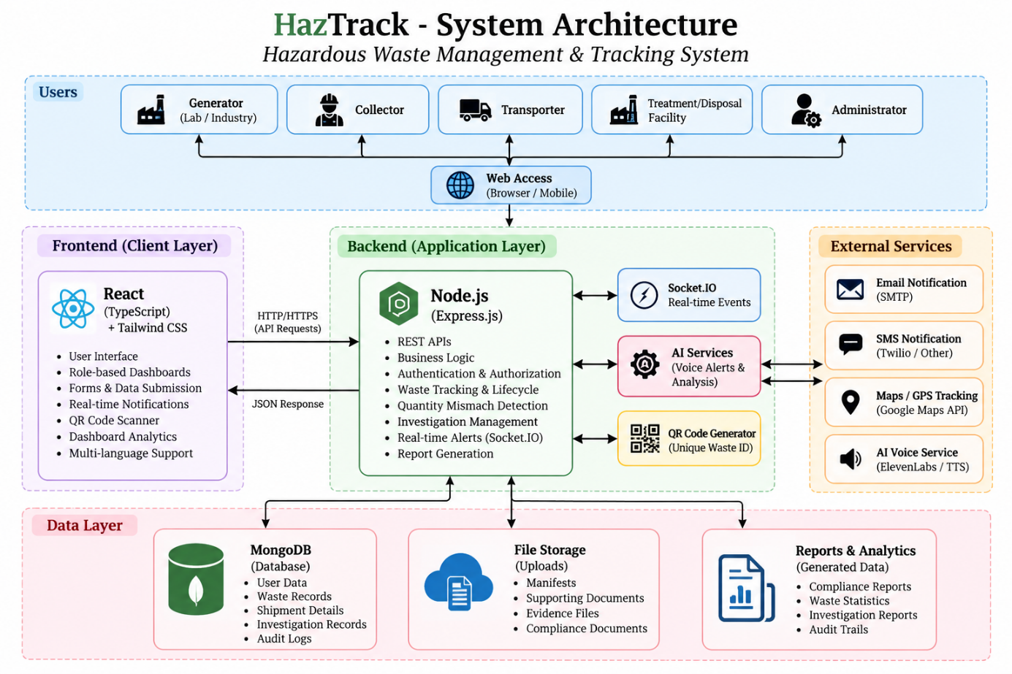
Fig 4.1 – System Architecture

4.2 MODULE DESCRIPTION
User and role management: Maintains accounts and permissions for Generator, Transporter, TSDF and Regulator. Sensitive actions are checked on the server.
Waste batch management: Stores waste type, quantity, origin, handling notes and documents. A unique identifier supports record retrieval.

Collection and transport: Records pickup, dispatch, assigned transporter, shipment status and available location updates.
Receipt and treatment/disposal: Captures received quantity, condition, acceptance/rejection reason and final processing status.
Compliance and audit: Maintains evidence and a chronological record of actions. Hash verification helps detect alteration.
Alert and investigation: Applies rules to discrepancies, delays and missing evidence, creates an investigation task and notifies the relevant user.

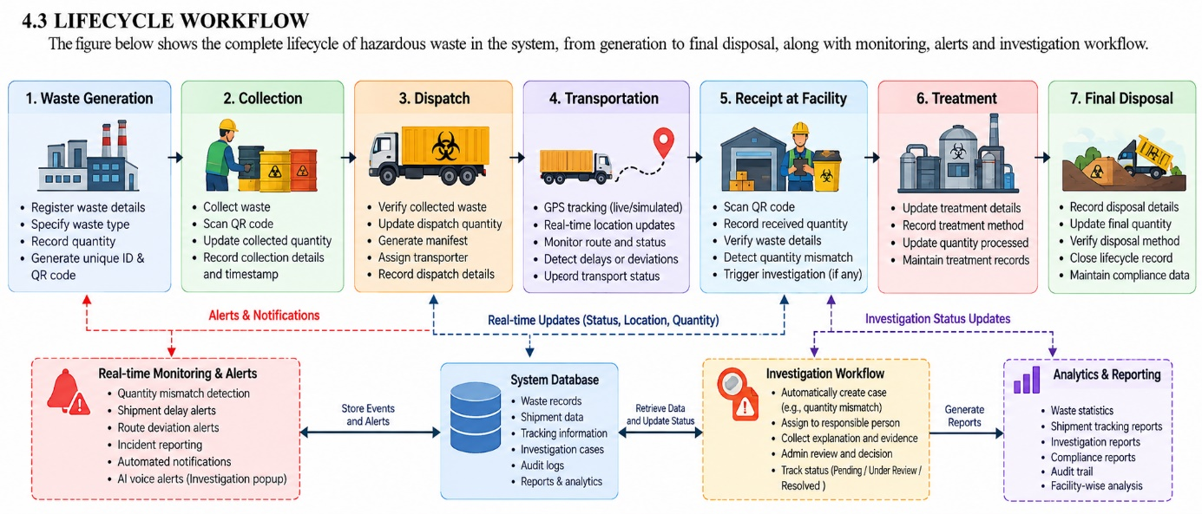
Fig 4.2 – Lifecycle Workflow

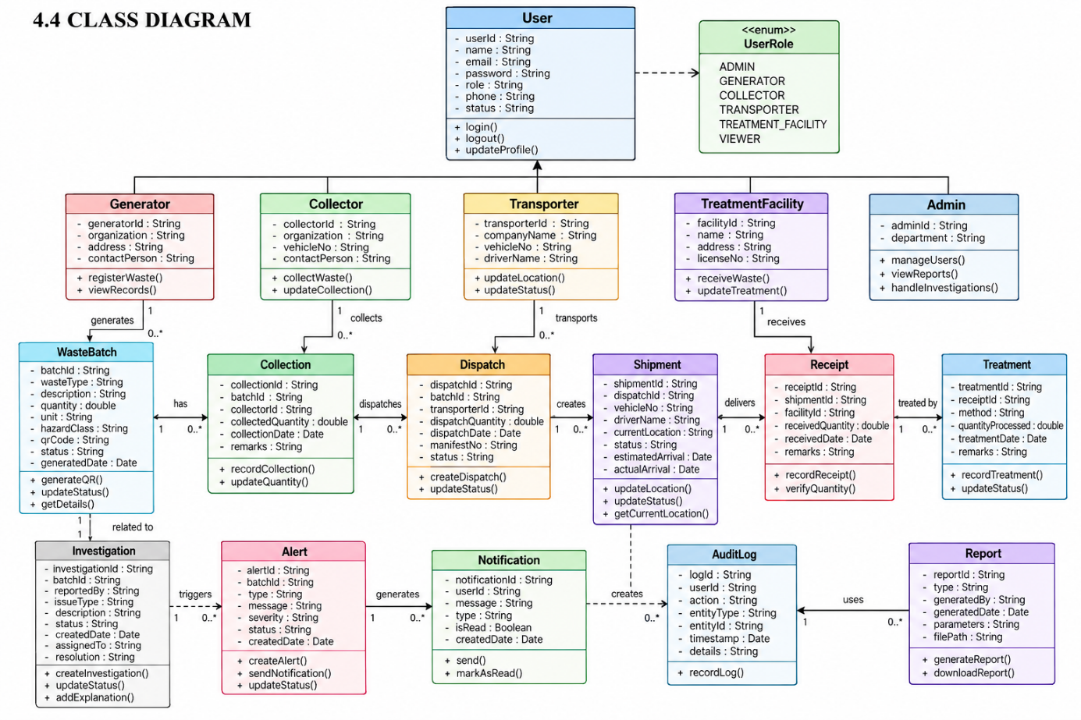
Fig 4.3 – Class Diagram

4.5 SEQUENCE DIAGRAM
The sequence illustrates a typical handover: the generator creates a batch, the API validates and stores the event, a transporter updates movement status, and the receiving facility verifies delivered quantity. If values differ beyond the configured tolerance, the server creates an investigation event and sends a targeted alert.

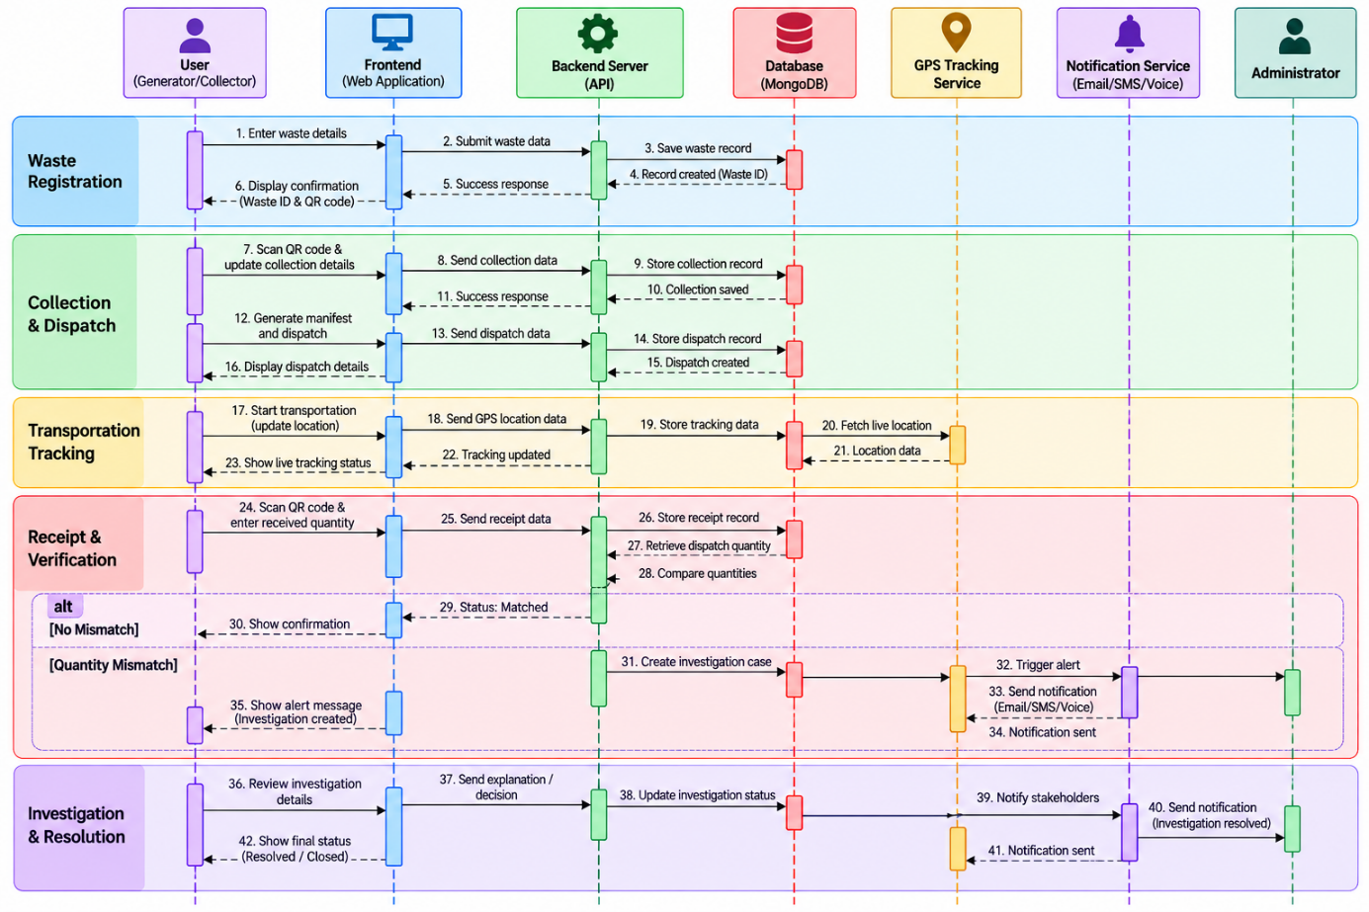
Fig 4.4 – Sequence Diagram

4.6 DATA INTEGRITY AND ACCESS CONTROL
Every state-changing operation should be checked against the current record state. For example, a shipment must not be marked received before dispatch. An audit event should include actor, timestamp, action, record identifier and hash. Hashing makes unexpected modification detectable, but it does not by itself prevent privileged database changes or prove the original entry was truthful.
Role-based access control must be enforced by backend routes, not merely by hiding frontend buttons. Users should receive only records and notifications permitted by their role and organization. JWTs must be validated on protected routes and secrets kept out of source code. Production deployment also requires HTTPS, backups, monitoring and a retention policy.

4.7 ALERT RULE EXAMPLE
If 10.0 kg is dispatched and 7.5 kg is received, the difference is 2.5 kg. If it exceeds the configured tolerance, the backend records an exception and routes an investigation request to an authorized administrator. The alert should identify the batch, quantities, difference, time and required action. This is an illustrative example; thresholds must be configurable.

CHAPTER 5
IMPLEMENTATION

5.1 IMPLEMENTATION OVERVIEW
The proposed implementation uses a React single-page interface with an Express backend. REST endpoints handle standard create, read, update and workflow actions, while Socket.IO carries real-time event notifications. The data layer stores users, waste batches, shipments, facilities, documents, investigations and audit events. A JSON-backed store may be used in a prototype; multi-user deployment should use properly configured persistent storage.
The frontend presents role-specific dashboards and forms. Axios communicates with the backend, and Socket.IO listens for authorized updates. The server validates input, checks permissions, confirms the requested state transition and persists the event before notifying affected users. QR codes are identifiers, not security credentials; record access still requires server authorization.

5.2 KEY FUNCTIONS (CODE EXPLANATION)
Waste record creation: validates required fields, creates a unique identifier and saves the initial state as Generated.
State transition validation: allows expected transitions such as Generated → Collected → In Transit → Received → Treated/Disposed. Invalid transitions are rejected.
Quantity reconciliation: compares dispatch and receipt quantities and opens an exception when the configured tolerance is exceeded.
Audit event generation: creates a timestamped event and computes a SHA-256 hash over a canonical representation of event data.
Targeted notifications: emits the event to authorized users or rooms associated with the relevant organization and role.
Voice alert: reads high-priority messages through browser speech synthesis when enabled. A visible alert remains necessary because autoplay may be blocked.

5.3 TESTING STRATEGY
Testing should cover valid and invalid form submissions, role-access checks, allowed and forbidden lifecycle transitions, QR lookup, quantity mismatch handling, missing-document alerts, disconnected clients, persistence after restart and audit-hash verification. Record each test case,

input, expected result, actual result and pass/fail status. Do not claim a test passed unless it was executed.

CHAPTER 6
CONCLUSION & FUTURE WORK

6.1 CONCLUSION
HazTrack proposes a unified digital approach for managing hazardous waste records from generation to final treatment or disposal. Its main contribution is the combination of lifecycle state tracking, role-based access, handover quantity reconciliation, supporting evidence, audit history and event-driven exception alerts. QR-linked identification can make records easier to retrieve, while transport updates improve operational visibility. A tamper-evident audit trail supports review of who performed an action and when. These features can reduce dependence on disconnected records and help organizations investigate inconsistencies systematically. Effectiveness depends on accurate data entry, appropriate access control, reliable persistence and validation against applicable rules.

6.2 FUTURE ENHANCEMENTS
Integrate GPS devices and verified telematics for live shipment tracking.
Add configurable regulatory forms, document expiry reminders and jurisdiction-specific reports.
Use digital signatures and stronger key management for critical handovers.
Add offline data capture with controlled synchronization.
Introduce analytics for recurring discrepancies, delays and facility trends.
Conduct security, performance, backup-recovery and usability testing.
Integrate with authorized external compliance systems where access is available.
Support multilingual interface text and user-configurable voice alerts.
The next phase should prioritize production-grade persistence, threat modeling, field validation and regulatory review before operational use.

APPENDIX

SOURCE CODE:
# Public Feedback System — Full Source Code Documentation

A complete, production-ready full-stack reference implementation built on the **MERN Stack (MongoDB, Express.js, React, Node.js)**.

---

## 1. Project Structure

public-feedback-system/
│
├── backend/
│ ├── config/
│ │ └── db.js
│ ├── controllers/
│ │ ├── authController.js
│ │ └── feedbackController.js
│ ├── middleware/
│ │ └── authMiddleware.js
│ ├── models/
│ │ ├── User.js
│ │ └── Feedback.js
│ ├── routes/
│ │ ├── authRoutes.js
│ │ └── feedbackRoutes.js
│ ├── .env
│ ├── package.json
│ └── server.js
│
└── frontend/
├── src/
│ ├── components/
│ │ └── Navbar.jsx
│ ├── pages/
│ │ ├── Login.jsx
│ │ └── AdminDashboard.jsx
│ ├── services/
│ │ └── api.js
│ ├── App.jsx
│ └── main.jsx
├── package.json
└── index.html

2. Backend Package Installation

Execute these commands in your terminal to set up the backend environment:

# 1. Create and navigate to the project directory
mkdir -p public-feedback-system/backend
cd public-feedback-system/backend

# 2. Initialize Node.js package.json
npm init -y

# 3. Install core dependencies
npm install express mongoose dotenv cors bcryptjs jsonwebtoken

# 4. Install nodemon for live development reloading
npm install --save-dev nodemon
```

In `backend/package.json`, update the `scripts` section:
```json
"scripts": {
"start": "node server.js",
"dev": "nodemon server.js"
}
```

---

## 3. Database Connection
backend/config/db.js`**

const mongoose = require('mongoose');

const connectDB = async () => {
try {
const conn = await mongoose.connect(process.env.MONGO_URI);
console.log(`[MongoDB Connected]: ${conn.connection.host}`);
} catch (error) {
console.error(`[Database Error]: ${error.message}`);
process.exit(1);
}
};

module.exports = connectDB;

4. Environment Variables
backend/.env`**

```env
PORT=5000
MONGO_URI=mongodb://127.0.0.1:27017/public_feedback_db
JWT_SECRET=super_secret_jwt_key_2026_secure
JWT_EXPIRE=7d

5. User Model
backend/models/User.js`**

const mongoose = require('mongoose');

const userSchema = new mongoose.Schema(
{
name: {
type: String,
required: [true, 'Please enter your full name'],
trim: true,
},
email: {
type: String,
required: [true, 'Please provide an email address'],
unique: true,
lowercase: true,
trim: true,
match: [
/^\w+([\.-]?\w+)*@\w+([\.-]?\w+)*(\.\w{2,3})+$/,
'Please enter a valid email address',
],
},
password: {
type: String,
required: [true, 'Please enter a password'],
minlength: [6, 'Password must be at least 6 characters'],
},
role: {
type: String,
enum: ['user', 'admin'],
default: 'user',
},
},
{
timestamps: true,
}
);

module.exports = mongoose.model('User', userSchema);

6. Password Hashing and Registration
backend/controllers/authController.js` (Part 1 - Registration)**

const User = require('../models/User');
const bcrypt = require('bcryptjs');
const jwt = require('jsonwebtoken');

// Helper to generate JWT Token
const generateToken = (id, role) => {
return jwt.sign({ id, role }, process.env.JWT_SECRET, {
expiresIn: process.env.JWT_EXPIRE || '7d',
});
};

// @desc Register a new user / citizen
// @route POST /api/auth/register
// @access Public
exports.registerUser = async (req, res) => {
try {
const { name, email, password, role } = req.body;

// 1. Validation
if (!name || !email || !password) {
return res.status(400).json({ success: false, message: 'All fields are required.' });
}

// 2. Check if user already exists
const existingUser = await User.findOne({ email });
if (existingUser) {
return res.status(400).json({ success: false, message: 'Email is already registered.' });
}

// 3. Password Hashing with Salt
const salt = await bcrypt.genSalt(10);
const hashedPassword = await bcrypt.hash(password, salt);

// 4. Create User
const user = await User.create({
name,
email,
password: hashedPassword,
role: role || 'user',
});

// 5. Send response with Token
const token = generateToken(user._id, user.role);

res.status(201).json({
success: true,
message: 'User registered successfully.',
token,
user: {
id: user._id,
name: user.name,
email: user.email,
role: user.role,
},
});
} catch (error) {
res.status(500).json({ success: false, message: error.message });
}
};

7. Login and JWT Generation
backend/controllers/authController.js` (Part 2 - Login)**

// @desc Authenticate user & get token
// @route POST /api/auth/login
// @access Public
exports.loginUser = async (req, res) => {
try {
const { email, password } = req.body;

// 1. Validate inputs
if (!email || !password) {
return res.status(400).json({ success: false, message: 'Please provide email and password.' });
}

// 2. Check if user exists
const user = await User.findOne({ email });
if (!user) {
return res.status(401).json({ success: false, message: 'Invalid credentials.' });
}

// 3. Compare password with hashed password
const isMatch = await bcrypt.compare(password, user.password);
if (!isMatch) {
return res.status(401).json({ success: false, message: 'Invalid credentials.' });
}

// 4. Generate JWT Token
const token = generateToken(user._id, user.role);

res.status(200).json({
success: true,
message: 'Login successful.',
token,
user: {
id: user._id,
name: user.name,
email: user.email,
role: user.role,
},
});
} catch (error) {
res.status(500).json({ success: false, message: error.message });
}
};

8. Authentication Middleware
backend/middleware/authMiddleware.js`**

const jwt = require('jsonwebtoken');
const User = require('../models/User');

// Protect route: Verifies Bearer Token
exports.protect = async (req, res, next) => {
let token;

if (
req.headers.authorization &&
req.headers.authorization.startsWith('Bearer')
) {
token = req.headers.authorization.split(' ')[1];
}

if (!token) {
return res.status(401).json({ success: false, message: 'Access denied. No authorization token provided.' });
}

try {
const decoded = jwt.verify(token, process.env.JWT_SECRET);
req.user = await User.findById(decoded.id).select('-password');

if (!req.user) {
return res.status(401).json({ success: false, message: 'User belonging to this token no longer exists.' });
}

next();
} catch (error) {
return res.status(401).json({ success: false, message: 'Invalid or expired token.' });
}
};

// Admin Guard: Restricts access to administrator accounts
exports.adminOnly = (req, res, next) => {
if (req.user && req.user.role === 'admin') {
next();
} else {
res.status(403).json({ success: false, message: 'Forbidden. Admin privileges required.' });
}
};

9. Create Feedback API (Model & Controller)
backend/models/Feedback.js`**

const mongoose = require('mongoose');

const feedbackSchema = new mongoose.Schema(
{
title: {
type: String,
required: [true, 'Please enter a feedback title'],
trim: true,
},
description: {
type: String,
required: [true, 'Please enter the detailed feedback description'],
},
category: {
type: String,
required: true,
enum: ['Infrastructure', 'Sanitation', 'Transportation', 'Public Safety', 'Other'],
default: 'Other',
},
department: {
type: String,
default: 'General Public Services',
},
status: {
type: String,
enum: ['Pending', 'In Progress', 'Resolved'],
default: 'Pending',
},
user: {
type: mongoose.Schema.Types.ObjectId,
ref: 'User',
required: true,
},
citizenName: {
type: String,
},
},
{
timestamps: true,
}
);

module.exports = mongoose.model('Feedback', feedbackSchema);

backend/controllers/feedbackController.js` (Create Operation)**

const Feedback = require('../models/Feedback');

// @desc Submit new citizen feedback
// @route POST /api/feedback
// @access Private (Registered Citizen / User)
exports.createFeedback = async (req, res) => {
try {
const { title, description, category, department } = req.body;

if (!title || !description) {
return res.status(400).json({ success: false, message: 'Title and description are required.' });
}

const feedback = await Feedback.create({
title,
description,
category,
department,
user: req.user._id,
citizenName: req.user.name,
});

res.status(201).json({
success: true,
message: 'Feedback submitted successfully.',
data: feedback,
});
} catch (error) {
res.status(500).json({ success: false, message: error.message });
}
};

10. Read Feedback API
backend/controllers/feedbackController.js` (Read Operations)**

// @desc Get all feedback records (with optional query filtering)
// @route GET /api/feedback
// @access Private
exports.getAllFeedback = async (req, res) => {
try {
const { status, category } = req.query;
const filter = {};

if (status) filter.status = status;
if (category) filter.category = category;

const feedbacks = await Feedback.find(filter)
.populate('user', 'name email')
.sort({ createdAt: -1 });

res.status(200).json({
success: true,
count: feedbacks.length,
data: feedbacks,
});
} catch (error) {
res.status(500).json({ success: false, message: error.message });
}
};

// @desc Get feedbacks submitted by the logged-in citizen
// @route GET /api/feedback/my
// @access Private
exports.getMyFeedback = async (req, res) => {
try {
const feedbacks = await Feedback.find({ user: req.user._id }).sort({ createdAt: -1 });

res.status(200).json({
success: true,
count: feedbacks.length,
data: feedbacks,
});
} catch (error) {
res.status(500).json({ success: false, message: error.message });
}
};

// @desc Get a single feedback by ID
// @route GET /api/feedback/:id
// @access Private
exports.getFeedbackById = async (req, res) => {
try {
const feedback = await Feedback.findById(req.params.id).populate('user', 'name email');

if (!feedback) {
return res.status(404).json({ success: false, message: 'Feedback not found.' });
}

res.status(200).json({
success: true,
data: feedback,
});
} catch (error) {
res.status(500).json({ success: false, message: error.message });
}
};

11. Update Feedback API
backend/controllers/feedbackController.js` (Update Operation)**

// @desc Update feedback status & assigned department
// @route PUT /api/feedback/:id
// @access Private (Admin Only)
exports.updateFeedbackStatus = async (req, res) => {
try {
const { status, department } = req.body;

const feedback = await Feedback.findById(req.params.id);

if (!feedback) {
return res.status(404).json({ success: false, message: 'Feedback not found.' });
}

if (status) feedback.status = status;
if (department) feedback.department = department;

const updatedFeedback = await feedback.save();

res.status(200).json({
success: true,
message: `Feedback status updated to ${updatedFeedback.status}.`,
data: updatedFeedback,
});
} catch (error) {
res.status(500).json({ success: false, message: error.message });
}
};

12. Delete Feedback API
backend/controllers/feedbackController.js` (Delete Operation)**

// @desc Delete a feedback submission
// @route DELETE /api/feedback/:id
// @access Private (Admin or Creator)
exports.deleteFeedback = async (req, res) => {
try {
const feedback = await Feedback.findById(req.params.id);

if (!feedback) {
return res.status(404).json({ success: false, message: 'Feedback not found.' });
}

// Only allow Admin OR the citizen who submitted it to delete
if (req.user.role !== 'admin' && feedback.user.toString() !== req.user._id.toString()) {
return res.status(403).json({ success: false, message: 'Not authorized to delete this feedback.' });
}

await feedback.deleteOne();

res.status(200).json({
success: true,
message: 'Feedback deleted successfully.',
});
} catch (error) {
res.status(500).json({ success: false, message: error.message });
}
};

13. Express Routes

backend/routes/authRoutes.js`**

const express = require('express');
const router = express.Router();
const { registerUser, loginUser } = require('../controllers/authController');

router.post('/register', registerUser);
router.post('/login', loginUser);

module.exports = router;
```

backend/routes/feedbackRoutes.js`**

const express = require('express');
const router = express.Router();
const {
createFeedback,
getAllFeedback,
getMyFeedback,
getFeedbackById,
updateFeedbackStatus,
deleteFeedback,
} = require('../controllers/feedbackController');
const { protect, adminOnly } = require('../middleware/authMiddleware');

// User & Public routes
router.post('/', protect, createFeedback);
router.get('/', protect, getAllFeedback);
router.get('/my', protect, getMyFeedback);
router.get('/:id', protect, getFeedbackById);

// Admin-controlled update & delete
router.put('/:id', protect, adminOnly, updateFeedbackStatus);
router.delete('/:id', protect, deleteFeedback);

module.exports = router;

14. Main Server File
backend/server.js`**

const express = require('express');
const dotenv = require('dotenv');
const cors = require('cors');
const connectDB = require('./config/db');

// Load environment variables
dotenv.config();

// Connect to MongoDB
connectDB();

const app = express();

// Middlewares
app.use(cors());
app.use(express.json());

// Mount API Routes
app.use('/api/auth', require('./routes/authRoutes'));
app.use('/api/feedback', require('./routes/feedbackRoutes'));

// Root Health Check Route
app.get('/', (req, res) => {
res.send('Public Feedback System API is live.');
});

// Global Error Handler
app.use((err, req, res, next) => {
console.error(err.stack);
res.status(500).json({
success: false,
message: err.message || 'Internal Server Error',
});
});

const PORT = process.env.PORT || 5000;
app.listen(PORT, () => {
console.log(`Server running in ${process.env.NODE_ENV || 'development'} mode on port ${PORT}`);
});

15. React Login Component
frontend/src/pages/Login.jsx`**

import React, { useState } from 'react';
import axios from 'axios';

export const Login = ({ onLoginSuccess }) => {
const [formData, setFormData] = useState({
email: '',
password: '',
});
const [loading, setLoading] = useState(false);
const [errorMsg, setErrorMsg] = useState('');

const handleChange = (e) => {
setFormData({ ...formData, [e.target.name]: e.target.value });
};

const handleSubmit = async (e) => {
e.preventDefault();
setLoading(true);
setErrorMsg('');

try {
const response = await axios.post('http://localhost:5000/api/auth/login', formData);
const { token, user } = response.data;

// Store in localStorage
localStorage.setItem('token', token);
localStorage.setItem('user', JSON.stringify(user));

if (onLoginSuccess) {
onLoginSuccess(user);
} else {
window.location.href = user.role === 'admin' ? '/admin' : '/dashboard';
}
} catch (err) {
setErrorMsg(err.response?.data?.message || 'Invalid email or password.');
} finally {
setLoading(false);
}
};

return (
<div style={styles.container}>
<div style={styles.card}>
<h2 style={styles.title}>Public Feedback System</h2>
<p style={styles.subtitle}>Sign in to your citizen or admin account</p>

{errorMsg && <div style={styles.alert}>{errorMsg}</div>}

<form onSubmit={handleSubmit} style={styles.form}>
<div style={styles.inputGroup}>
<label style={styles.label}>Email Address</label>
<input
type="email"
name="email"
value={formData.email}
onChange={handleChange}
placeholder="e.g. citizen@city.gov"
required
style={styles.input}
/>
</div>

<div style={styles.inputGroup}>
<label style={styles.label}>Password</label>
<input
type="password"
name="password"
value={formData.password}
onChange={handleChange}
placeholder="••••••••"
required
style={styles.input}
/>
</div>

<button type="submit" disabled={loading} style={styles.button}>
{loading ? 'Authenticating...' : 'Sign In'}
</button>
</form>
</div>
</div>
);
};

const styles = {
container: {
minHeight: '100vh',
display: 'flex',
justifyContent: 'center',
alignItems: 'center',
backgroundColor: '#0f172a',
fontFamily: 'Segoe UI, sans-serif',
},
card: {
width: '100%',
maxWidth: '400px',
padding: '32px',
backgroundColor: '#1e293b',
borderRadius: '12px',
boxShadow: '0 8px 30px rgba(0,0,0,0.4)',
border: '1px solid #334155',
},
title: { color: '#f8fafc', margin: '0 0 8px 0', fontSize: '24px' },
subtitle: { color: '#94a3b8', fontSize: '13px', margin: '0 0 24px 0' },
alert: {
padding: '10px 14px',
backgroundColor: 'rgba(239, 68, 68, 0.2)',
border: '1px solid #ef4444',
color: '#fca5a5',
borderRadius: '6px',
fontSize: '13px',
marginBottom: '16px',
},
form: { display: 'flex', flexDirection: 'column', gap: '16px' },
inputGroup: { display: 'flex', flexDirection: 'column', gap: '6px' },
label: { color: '#cbd5e1', fontSize: '12px', fontWeight: '600' },
input: {
padding: '10px 12px',
backgroundColor: '#0f172a',
border: '1px solid #334155',
borderRadius: '6px',
color: '#ffffff',
outline: 'none',
fontSize: '14px',
},
button: {
marginTop: '8px',
padding: '12px',
backgroundColor: '#2563eb',
color: '#ffffff',
border: 'none',
borderRadius: '6px',
cursor: 'pointer',
fontWeight: '600',
fontSize: '14px',
},
};

16. Admin Dashboard Logic
frontend/src/pages/AdminDashboard.jsx`**

import React, { useEffect, useState } from 'react';
import axios from 'axios';

export const AdminDashboard = () => {
const [feedbacks, setFeedbacks] = useState([]);
const [loading, setLoading] = useState(true);
const [filter, setFilter] = useState('');

const token = localStorage.getItem('token');

// Fetch all feedback items from API
const fetchFeedbacks = async () => {
try {
setLoading(true);
const url = filter
? `http://localhost:5000/api/feedback?status=${filter}`
: 'http://localhost:5000/api/feedback';

const res = await axios.get(url, {
headers: { Authorization: `Bearer ${token}` },
});

setFeedbacks(res.data.data);
} catch (err) {
console.error('Error fetching feedbacks:', err);
} finally {
setLoading(false);
}
};

useEffect(() => {
fetchFeedbacks();
}, [filter]);

// Update status (Pending -> In Progress -> Resolved)
const handleStatusChange = async (id, newStatus) => {
try {
await axios.put(
`http://localhost:5000/api/feedback/${id}`,
{ status: newStatus },
{ headers: { Authorization: `Bearer ${token}` } }
);
fetchFeedbacks();
} catch (err) {
alert('Failed to update status.');
}
};

// Delete feedback
const handleDelete = async (id) => {
if (!window.confirm('Are you sure you want to delete this feedback record?')) return;
try {
await axios.delete(`http://localhost:5000/api/feedback/${id}`, {
headers: { Authorization: `Bearer ${token}` },
});
fetchFeedbacks();
} catch (err) {
alert('Failed to delete feedback.');
}
};

const counts = {
total: feedbacks.length,
pending: feedbacks.filter((f) => f.status === 'Pending').length,
inProgress: feedbacks.filter((f) => f.status === 'In Progress').length,
resolved: feedbacks.filter((f) => f.status === 'Resolved').length,
};

return (
<div style={{ padding: '32px', backgroundColor: '#0b132b', minHeight: '100vh', color: '#fff' }}>
<h1>Citizen Feedback Administration</h1>
<p style={{ color: '#8d99ae' }}>Manage public grievances, assignments, and resolution statuses</p>

{/* Metric Cards */}
<div style={{ display: 'grid', gridTemplateColumns: 'repeat(4, 1fr)', gap: '16px', margin: '24px 0' }}>
<div style={cardStyle}>Total: <b>{counts.total}</b></div>
<div style={{ ...cardStyle, borderLeft: '4px solid #f59e0b' }}>Pending: <b>{counts.pending}</b></div>
<div style={{ ...cardStyle, borderLeft: '4px solid #3b82f6' }}>In Progress: <b>{counts.inProgress}</b></div>
<div style={{ ...cardStyle, borderLeft: '4px solid #10b981' }}>Resolved: <b>{counts.resolved}</b></div>
</div>

{/* Filter Selector */}
<div style={{ marginBottom: '16px' }}>
<label style={{ marginRight: '10px' }}>Filter by Status:</label>
<select value={filter} onChange={(e) => setFilter(e.target.value)} style={selectStyle}>
<option value="">All Statuses</option>
<option value="Pending">Pending</option>
<option value="In Progress">In Progress</option>
<option value="Resolved">Resolved</option>
</select>
</div>

{/* Feedback Records Table */}
{loading ? (
<p>Loading grievances...</p>
) : (
<table style={{ width: '100%', borderCollapse: 'collapse', backgroundColor: '#1c2541' }}>
<thead>
<tr style={{ textAlign: 'left', borderBottom: '2px solid #3a506b', color: '#cbd5e1' }}>
<th style={thStyle}>Title</th>
<th style={thStyle}>Citizen</th>
<th style={thStyle}>Category</th>
<th style={thStyle}>Status</th>
<th style={thStyle}>Actions</th>
</tr>
</thead>
<tbody>
{feedbacks.map((f) => (
<tr key={f._id} style={{ borderBottom: '1px solid #3a506b' }}>
<td style={tdStyle}>
<b>{f.title}</b>
<div style={{ fontSize: '12px', color: '#8d99ae' }}>{f.description}</div>
</td>
<td style={tdStyle}>{f.citizenName || f.user?.name || 'Anonymous'}</td>
<td style={tdStyle}>{f.category}</td>
<td style={tdStyle}>
<select
value={f.status}
onChange={(e) => handleStatusChange(f._id, e.target.value)}
style={selectStyle}
>
<option value="Pending">Pending</option>
<option value="In Progress">In Progress</option>
<option value="Resolved">Resolved</option>
</select>
</td>
<td style={tdStyle}>
<button onClick={() => handleDelete(f._id)} style={deleteBtnStyle}>
Delete
</button>
</td>
</tr>
))}
</tbody>
</table>
)}
</div>
);
};

const cardStyle = { padding: '16px', backgroundColor: '#1c2541', borderRadius: '8px' };
const thStyle = { padding: '12px' };
const tdStyle = { padding: '12px' };
const selectStyle = { padding: '6px 10px', backgroundColor: '#0b132b', color: '#fff', border: '1px solid #3a506b', borderRadius: '4px' };
const deleteBtnStyle = { padding: '6px 12px', backgroundColor: '#ef4444', color: '#fff', border: 'none', borderRadius: '4px', cursor: 'pointer' };

17. REST API Request and Response Examples

1. User Registration
- **Request**: `POST /api/auth/register`
```json
{
"name": "Kavitha Raman",
"email": "kavitha@example.com",
"password": "Password123",
"role": "user"
}
```
- **Response** (`201 Created`):
```json
{
"success": true,
"message": "User registered successfully.",
"token": "eyJhbGciOiJIUzI1NiIsInR5cCI6IkpXVCJ9.eyJpZCI6IjY3MDU4Mm...",
"user": {
"id": "670582f3a9b1c2001",
"name": "Kavitha Raman",
"email": "kavitha@example.com",
"role": "user"
}
}
```

---

2. User Login
- **Request**: `POST /api/auth/login`
```json
{
"email": "kavitha@example.com",
"password": "Password123"
}
```
- **Response** (`200 OK`):
```json
{
"success": true,
"message": "Login successful.",
"token": "eyJhbGciOiJIUzI1NiIsInR5cCI6IkpXVCJ9.eyJpZCI6IjY3MDU4Mm...",
"user": {
"id": "670582f3a9b1c2001",
"name": "Kavitha Raman",
"email": "kavitha@example.com",
"role": "user"
}
}
```

---

3. Create Feedback
- **Headers**:
```http
Authorization: Bearer <TOKEN>
Content-Type: application/json
```
- **Request**: `POST /api/feedback`
```json
{
"title": "Broken Street Lamp near North Junction",
"description": "Streetlight #42 has been non-functional for 5 consecutive nights, causing road hazard.",
"category": "Infrastructure",
"department": "Electrical & Street Lighting"
}
```
- **Response** (`201 Created`):
```json
{
"success": true,
"message": "Feedback submitted successfully.",
"data": {
"_id": "670583e7a9b1c2002",
"title": "Broken Street Lamp near North Junction",
"description": "Streetlight #42 has been non-functional for 5 consecutive nights, causing road hazard.",
"category": "Infrastructure",
"department": "Electrical & Street Lighting",
"status": "Pending",
"user": "670582f3a9b1c2001",
"citizenName": "Kavitha Raman",
"createdAt": "2026-10-14T06:04:23.112Z",
"updatedAt": "2026-10-14T06:04:23.112Z"
}
}
```

---

4. Read All Feedback (with Filter)
- **Headers**:
```http
Authorization: Bearer <TOKEN>
```
- **Request**: `GET /api/feedback?status=Pending`
- **Response** (`200 OK`):
```json
{
"success": true,
"count": 1,
"data": [
{
"_id": "670583e7a9b1c2002",
"title": "Broken Street Lamp near North Junction",
"description": "Streetlight #42 has been non-functional for 5 consecutive nights, causing road hazard.",
"category": "Infrastructure",
"department": "Electrical & Street Lighting",
"status": "Pending",
"citizenName": "Kavitha Raman",
"user": {
"_id": "670582f3a9b1c2001",
"name": "Kavitha Raman",
"email": "kavitha@example.com"
},
"createdAt": "2026-10-14T06:04:23.112Z"
}
]
}
```

---

5. Update Feedback Status
- **Headers**:
```http
Authorization: Bearer <ADMIN_TOKEN>
Content-Type: application/json
```
- **Request**: `PUT /api/feedback/670583e7a9b1c2002`
```json
{
"status": "Resolved",
"department": "Municipal Electrical Maintenance Wing"
}
```
- **Response** (`200 OK`):
```json
{
"success": true,
"message": "Feedback status updated to Resolved.",
"data": {
"_id": "670583e7a9b1c2002",
"title": "Broken Street Lamp near North Junction",
"status": "Resolved",
"department": "Municipal Electrical Maintenance Wing",
"updatedAt": "2026-10-14T06:12:45.340Z"
}
}
```

---

6. Delete Feedback
- **Headers**:
```http
Authorization: Bearer <TOKEN>
```
- **Request**: `DELETE /api/feedback/670583e7a9b1c2002`
- **Response** (`200 OK`):
```json
{
"success": true,
"message": "Feedback deleted successfully."
}
```

SCREENSHOTS OF THE PROJECT

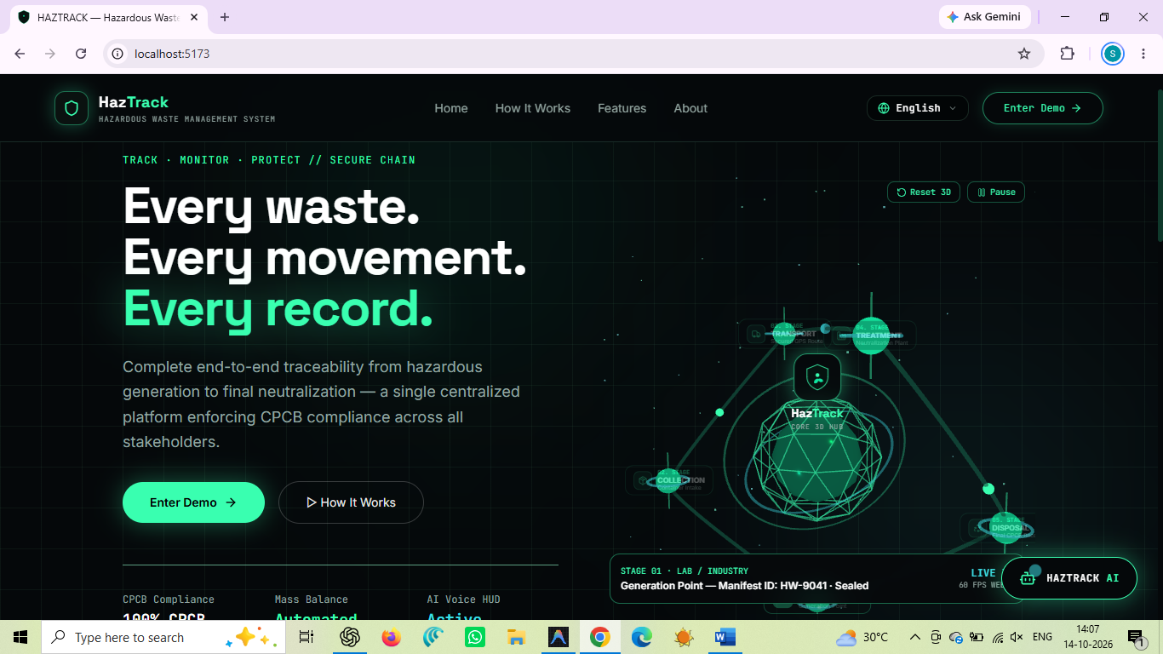

Fig 1 - Home Page

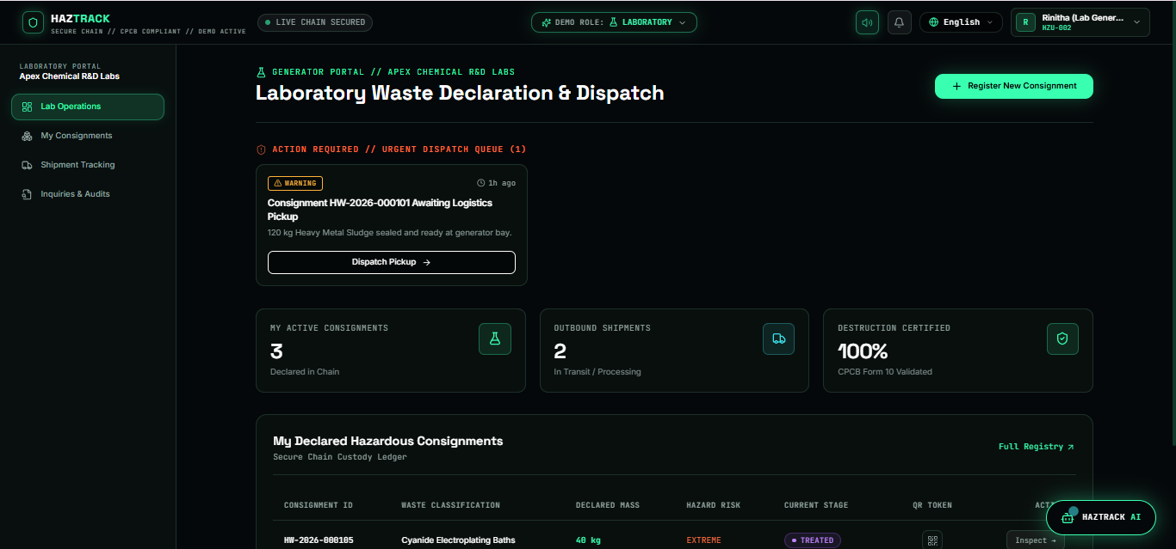

Fig – 2: Laboratory Waste Declaration & Dispatch

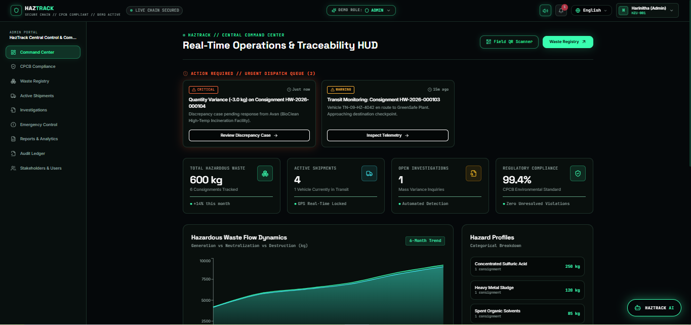

Fig – 3 : Real-Time Operations & Traceability HUD

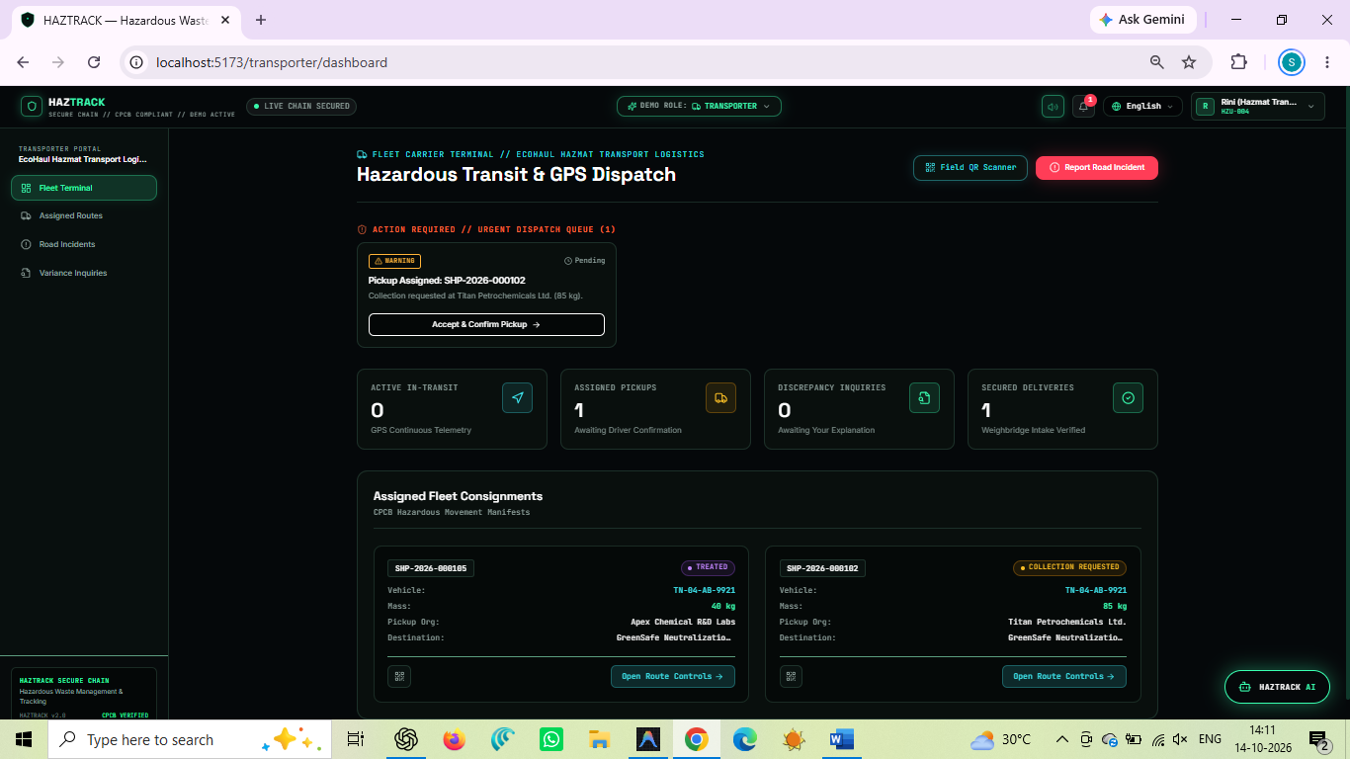

Fig – 4 : Hazardous Transit & GPS Dispatch

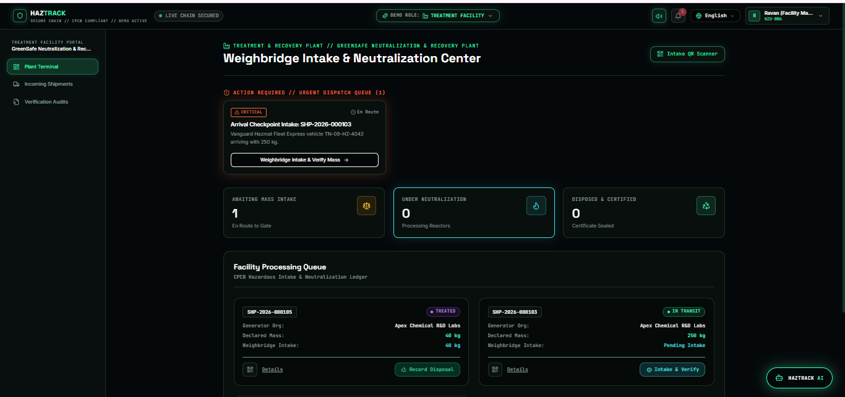

Fig – 5 : Weighbridge Intake & Neutralization Center

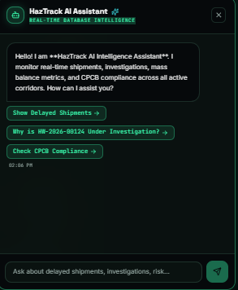

Fig - 6 : HazTrack AI Assistant

REFERENCES

